**EXPERIMENT-24**

**MICROSOFT AZURE**

Create a Storage service using any Public Cloud Service Provider (Azure/GCP/AWS) and check the public accessibility of the stored file to demonstrate Storage as a Service.

STEP-1: CREATE A STORAGE ACCOUNT GO TO THE BASICS.

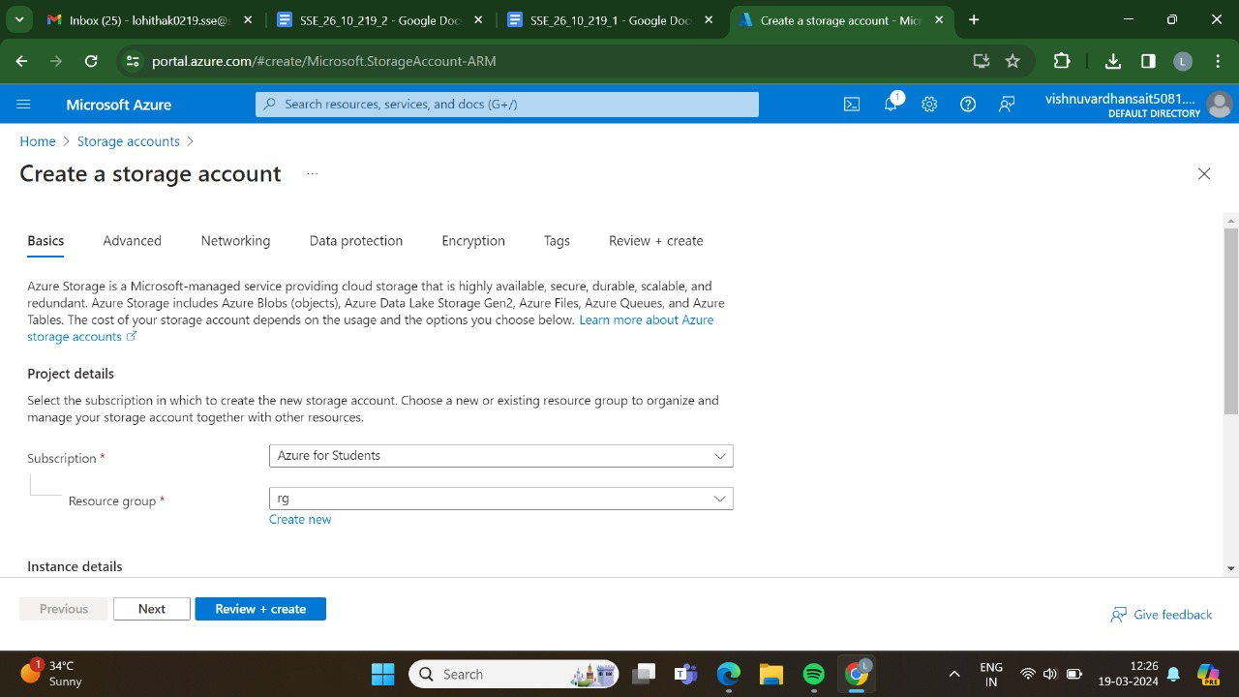

STEP-2:AND,THEN GO TO THE ADVANCED.

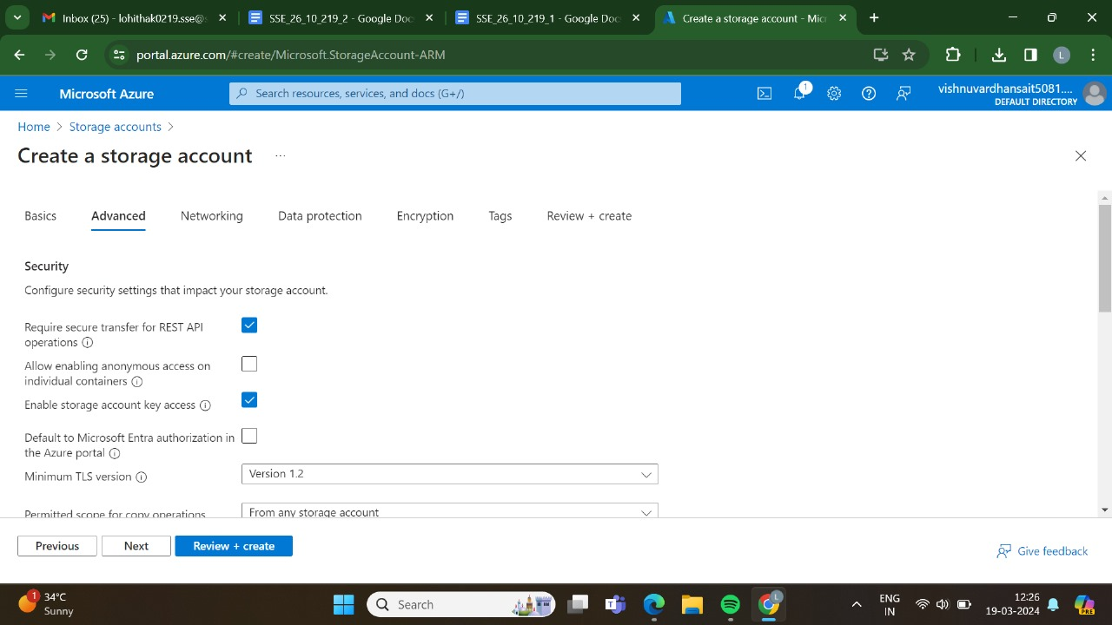

STEP-3:AND,THEN GO FOR THE NETWORKING.

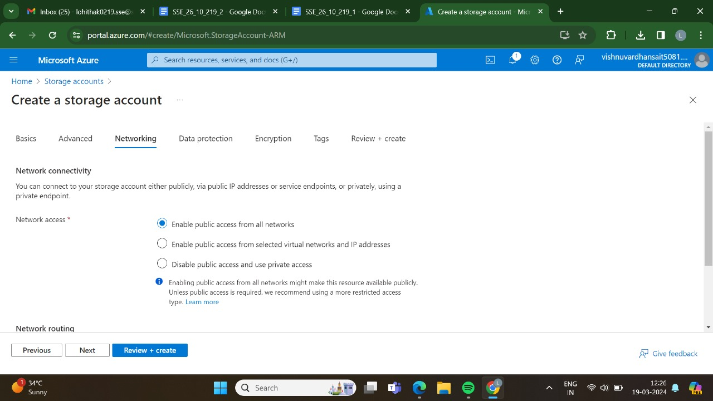

STEP-4:AND,THEN GO FOR THE DATA PROTECTION.

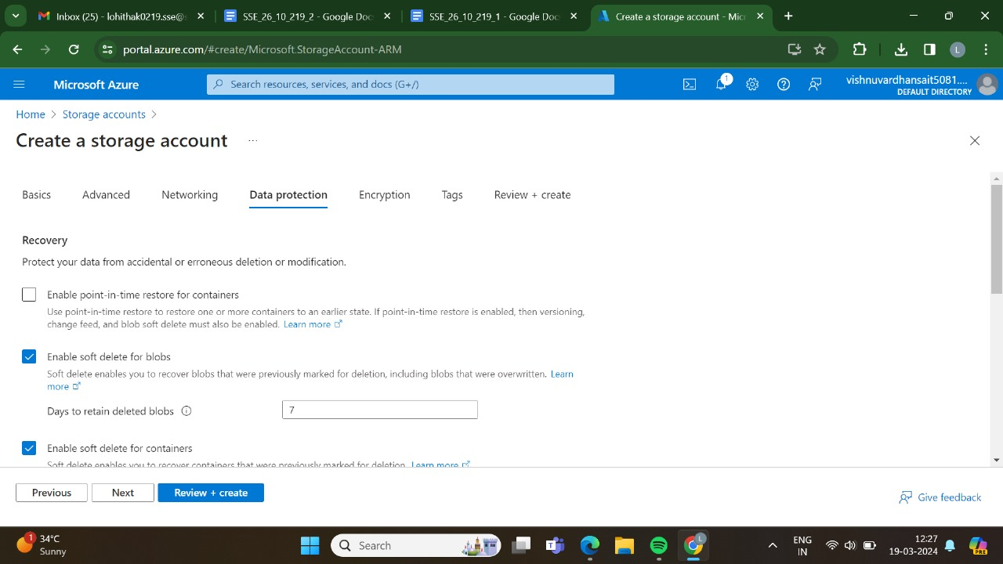

STEP-5:AND,THEN GO FOR THE ENCRYTION.

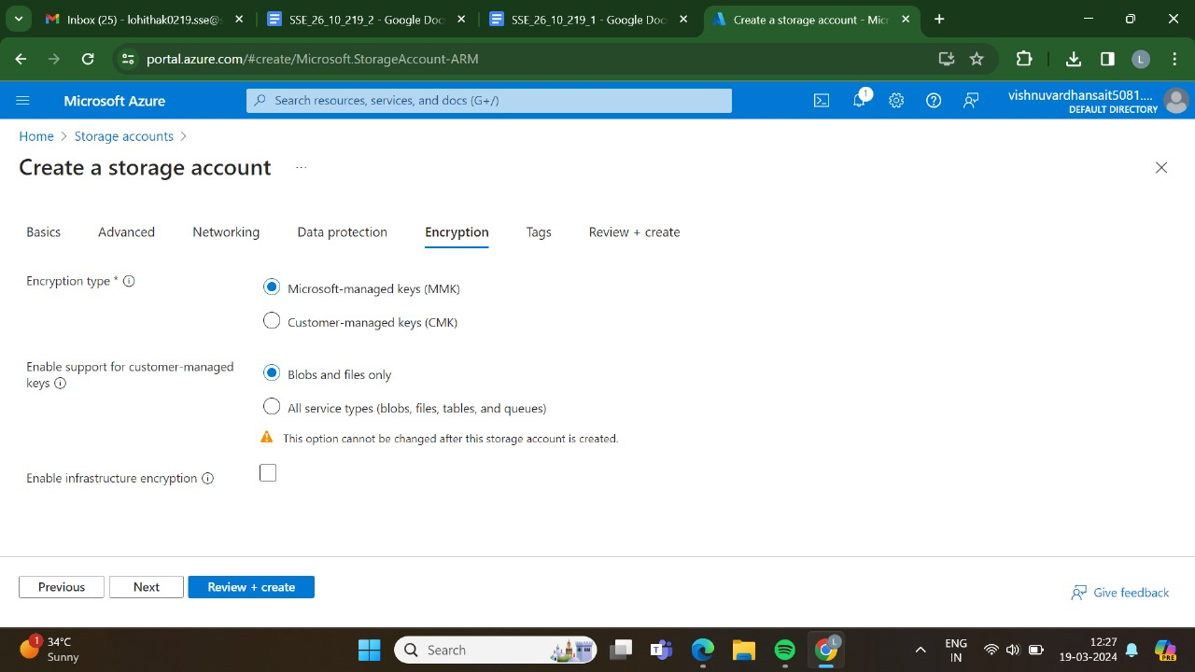

STEP-6:AND,THEN GO FOR THE TAGS.

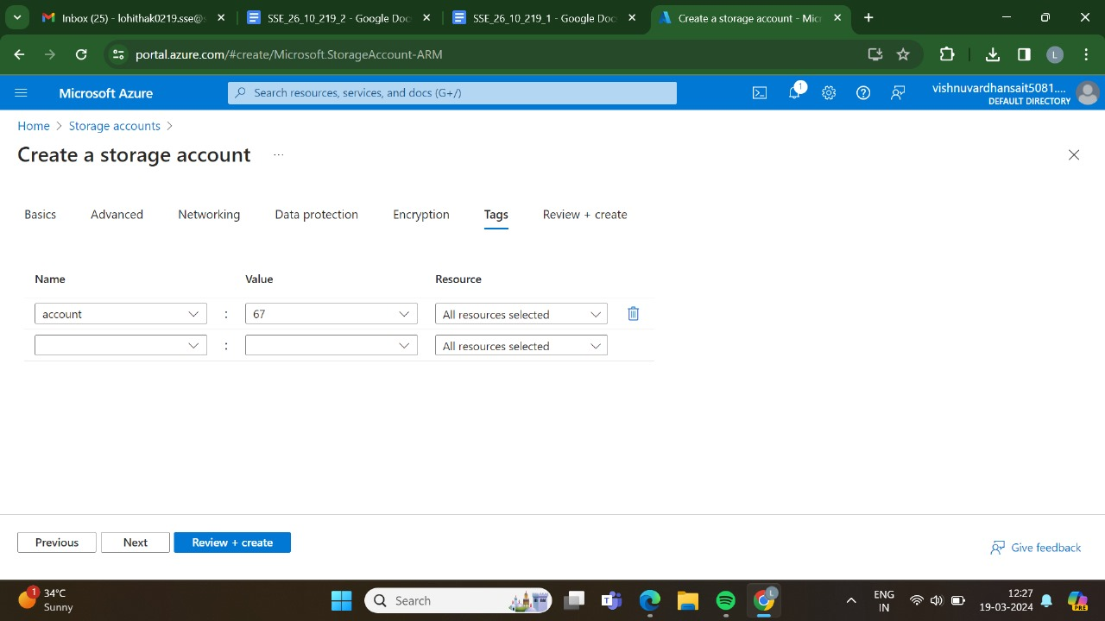

STEP-7:AND AT LAST GO FOR THE REVIEW + CREATE ,AND CLICK CREATE.

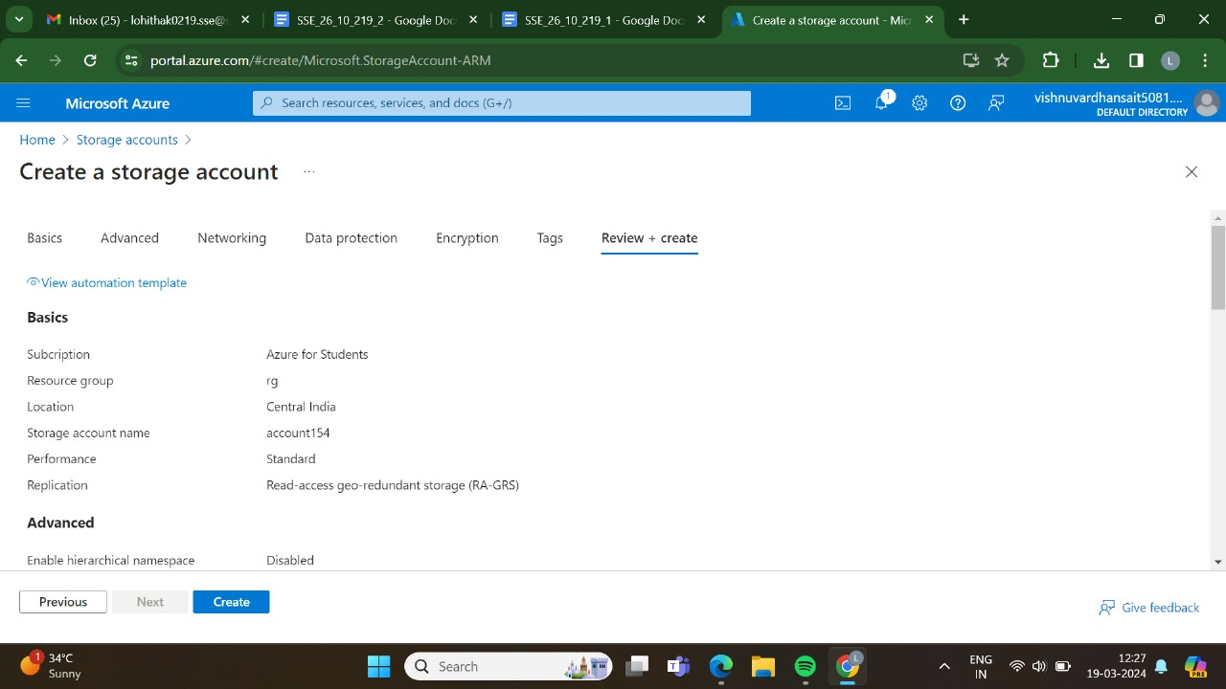

STEP-8:DEPLOYMENT IS IN PROGRESS.

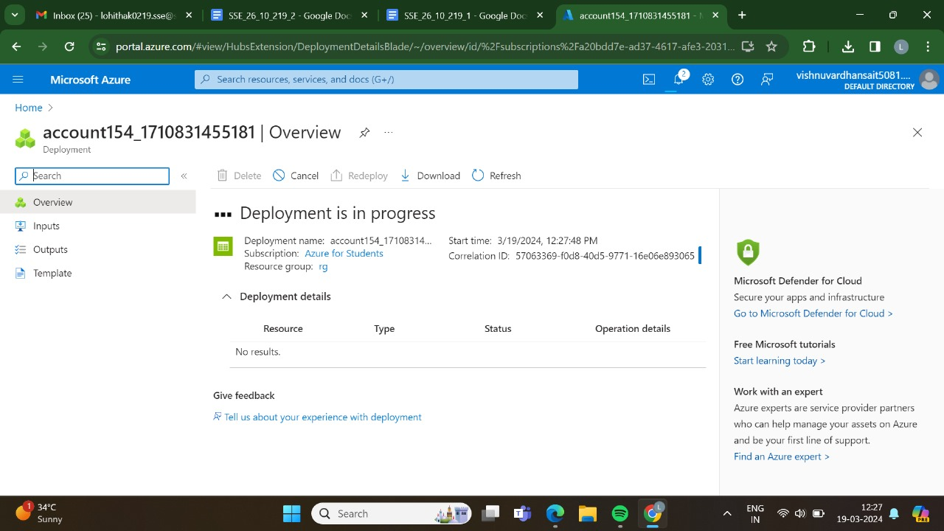

STEP-9:DEPLOYMENT HAS BEEN DONE SUCCESSFULLY.

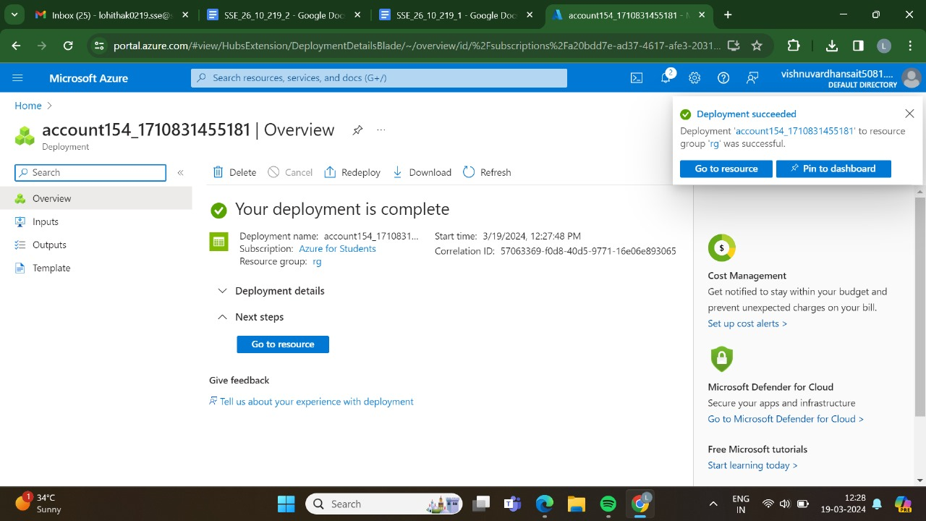

STEP-10:AND THEN GO FOR THE STORAGE BROWSER.

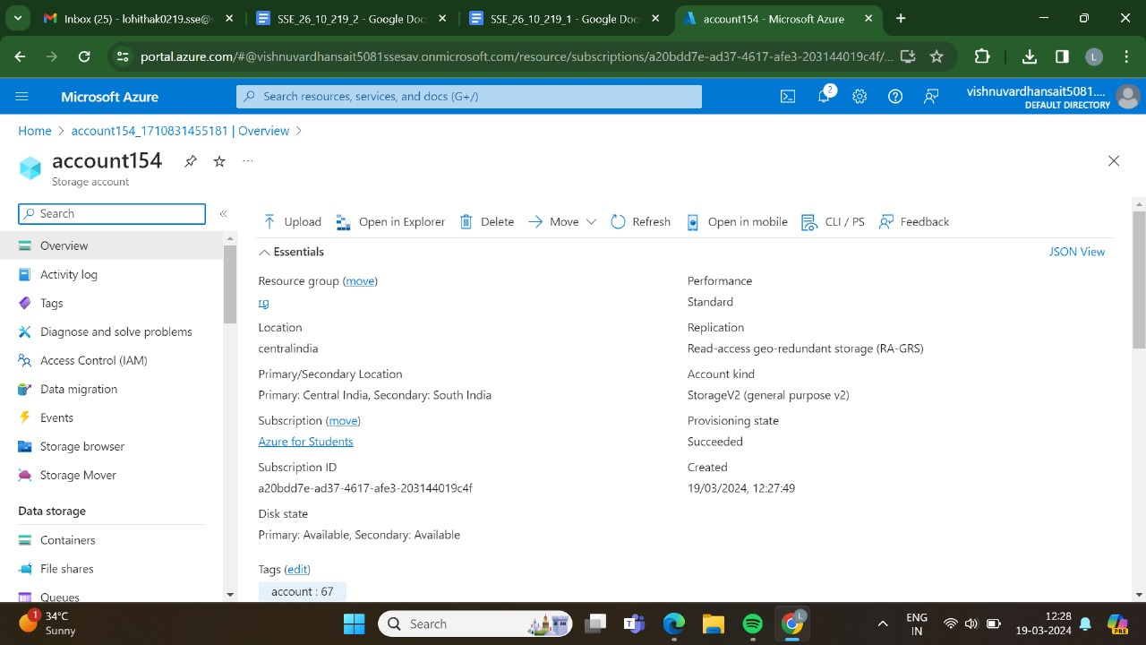

STEP-11: AND THEN GO TO THE FILE SHARES.

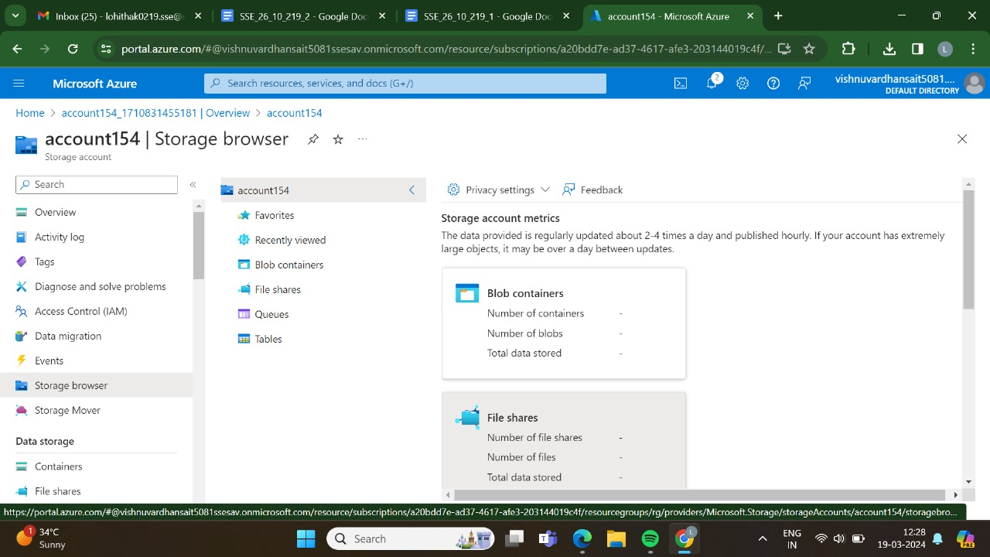

STEP-12: AND THEN CREATE A NEW FILE SHARE.

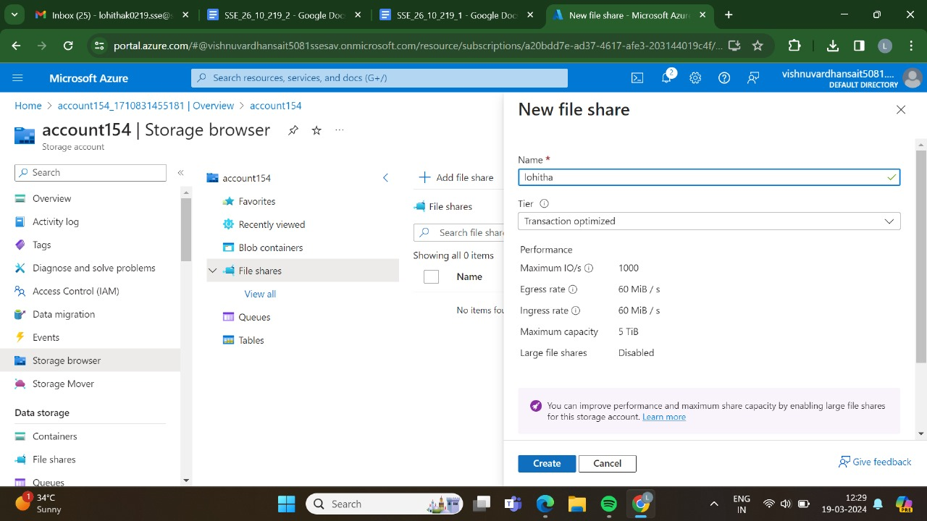

STEP-13:HAS BEEN DONE SUCCESSFULLY.

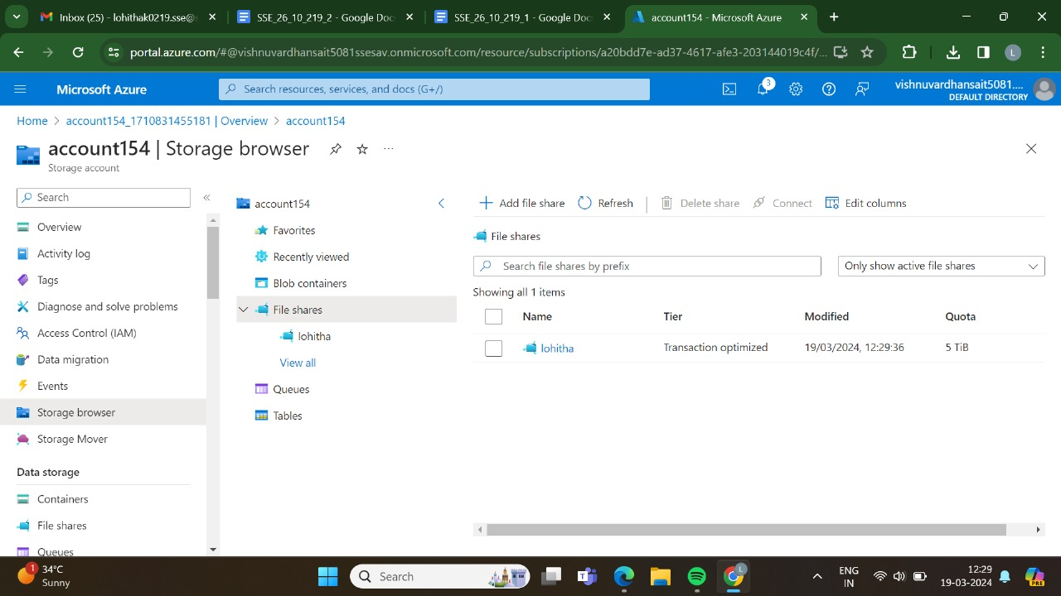

STEP-14: AND THEN GO AND UPLOAD THE FILES.

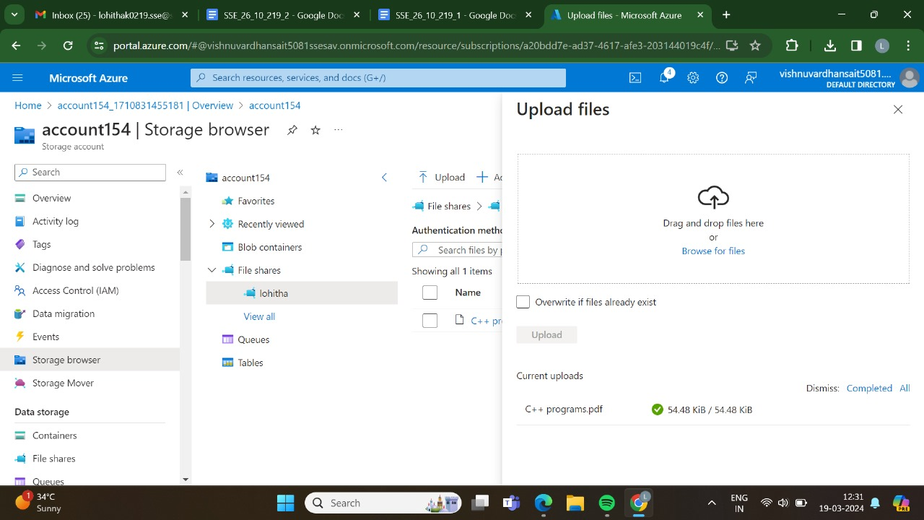

STEP-15:AT LAST THE FILE HAS BEEN UPLOADED SUCCESSFULLY.

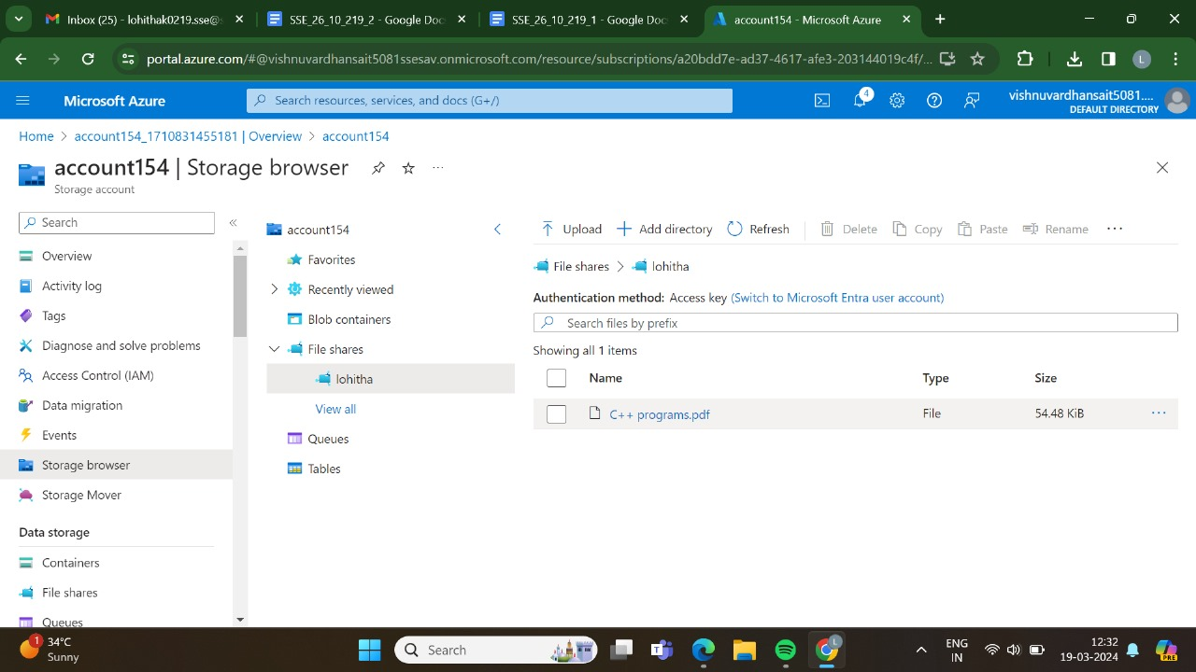

RESULT:THUS,THE PROGRAM HAS BEEN EXCEUTED SUCCESSFULLY.